NAKU

Game Instruction sheet

Game Resides here : <https://drive.google.com/folderview?id=0B13k0yJk6ShuaTV0aHdYUzRVT0E&usp=sharing> . Please download Naku_The_Game.zip

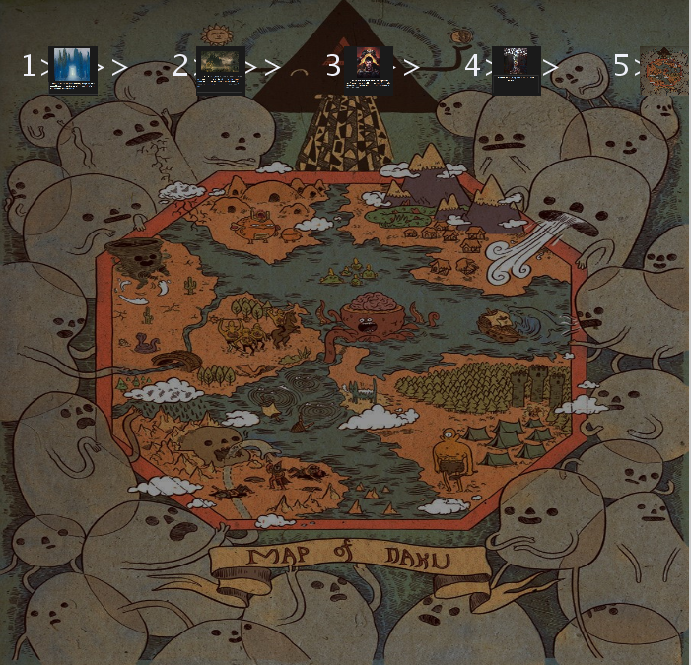

When game starts up, click on first thumbnail labeled “1’.

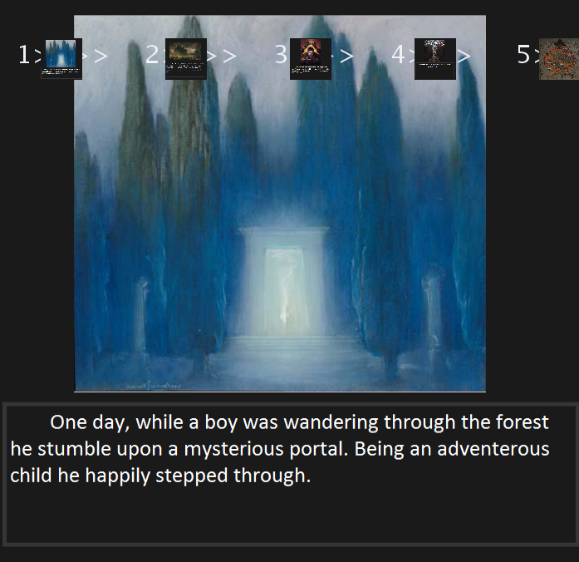

Follow through the numbered thumbnails, in order, to get the story and premise of the game.

Clicking on the last thumbnail starts the first level (challenge). You first reach the world called “Naku”

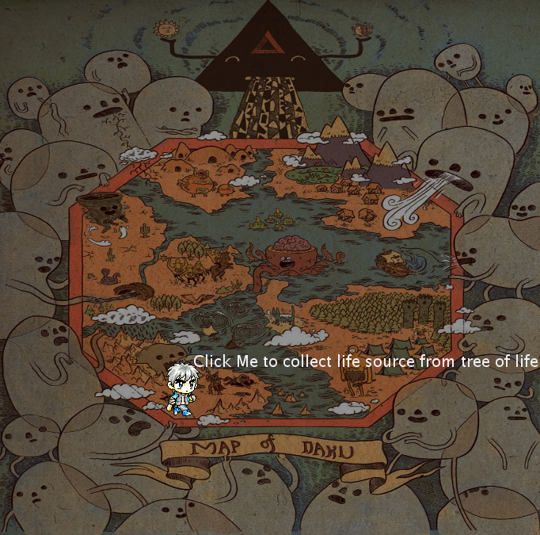

You are now in Naku and you task is to save the people by collecting life source from the tree of life.

To do that, you have collect as many scarce life sources as within a few seconds. The objective of this level is to collect twenty life sources before time runs out. Also, you will need to make sure you do not miss any of the life sources.

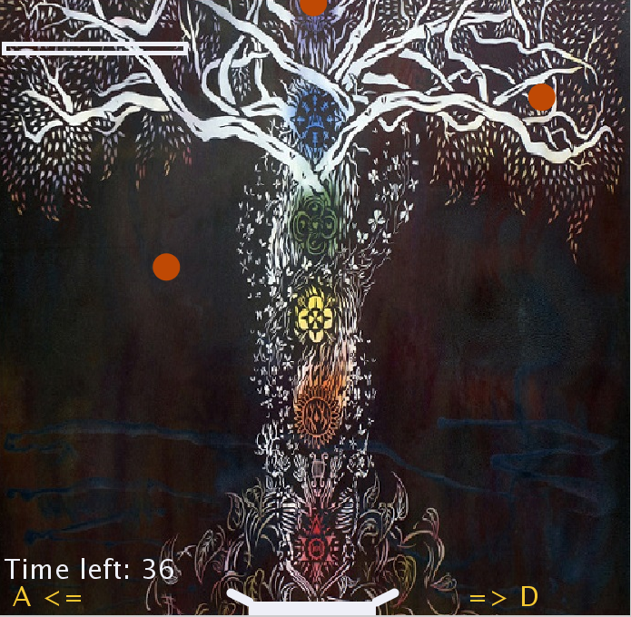

First challenge starts. This is the tree of life where you will collect the life source from. Use the ‘A’ and ‘D’ keys to move basket from left to right to get life sources to save the dying and hungry people of Naku. You have less than 45 seconds. Speed and agility are key to winning in the level.

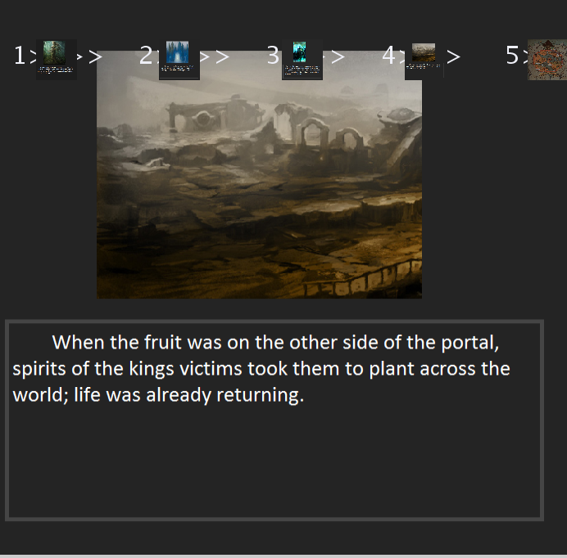

After collecting the required amount of life sources that will save all the lives of the nakulites, story continues. You get more screens of the story. Click on the numbered thumbnails to read through them at your own pace. Next, you have to complete another challenge to transfer the life source you already collected from the three of life to the dying people. A sea of death separate you from them. You have to stay on one side of Naku and transfer the life source to the other side.

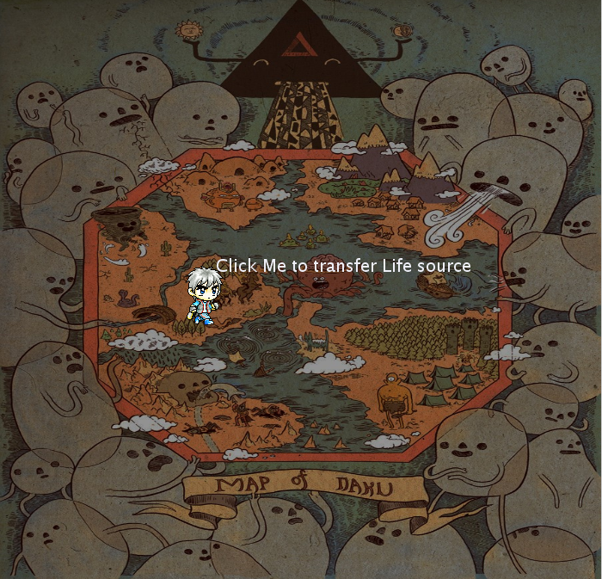

By completing the first challenge. You have now moved to a gate where you have to transfer the life source across. You can see a sea of death. Complete next challenge to carry life source across

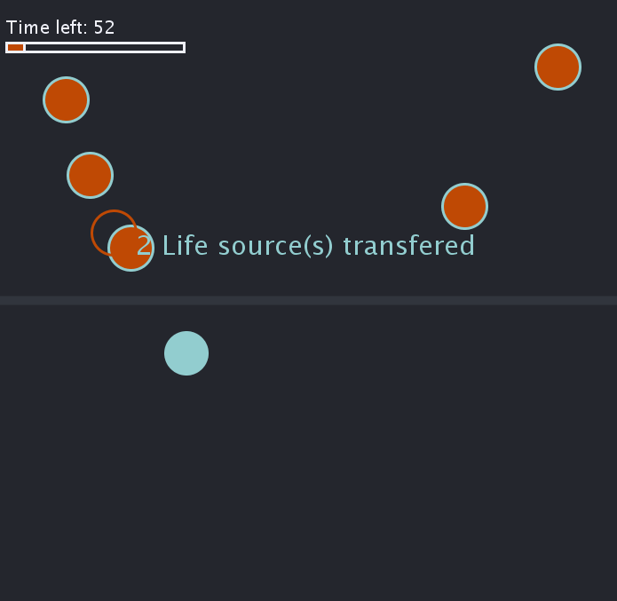

Complete this challenge to transfer life source and save lives. You do this by using mouse clicks. Click on lower half of screen to transfer life source from other half to lower half. Note that the screen is mirrored and your clicks on lower half of the screen must correspond to the position of the life source on the other side of the screen. The life sources are in rapid constant vibration in the chest.

The more of them your remove from the chest. The more space there is in the chest and that is the faster they vibrate in the chest. SPEED is key. Time is running out.

If time runs out all the life sources will escape and you need to collect them again by completing first challenge again.

Be ready to have a sore hand trying to trying the life sources!